SAINT GIRI SR. SEC. SCHOOL


COMPUTER SCIENCE

2024-2025

LIBRARY MANAGEMENT
BASED ON CONNECTIVITY OF PYTHON AND MYSQL

SUBMITTED BY
NAME: SHIVANGI BOARD ROLL NUMBER: CLASS: XII-B

ACKNOWLEDGEMENT
Apart from the efforts of me, the success of any project depends largely on the encouragement and guidelines of many others. I take this opportunity to express my gratitude to the people who have been instrumental in the successful completion of this project.
I express deep sense of gratitude to almighty God for giving me strength for the successful completion of the project.
I express my heartfelt gratitude to my parents for constant encouragement while carrying out this project.
I gratefully acknowledge the contribution of the individuals who contributed in bringing this project up to this level, who continues to look after me despite my flaws,
I express my deep sense of gratitude to the luminary . Ms. SANYOGITA, The Principal, Saint Giri Sr. Sec. School who has been continuously motivating and extending their helping hand to us.
My sincere thanks to MS. HARSHITA MAHINDRA , PGT Computer Science and IP, A guide, Mentor all the above a friend, who critically reviewed my project and helped in solving each and every problem, occurred during implementation of the project

The guidance and support received from all the members who contributed and who are contributing to this project, was vital for the success of the project.
I am grateful for their constant support and help.

STUDENT SIGNATURE

SAINT GIRI SR. SEC. SCHOOL

COMPUTER SCIENCE

CERTIFICATE

This is to certify that Shivangi, a student of class XII has successfully completed her project based on connectivity of Python andMySQL, under the guidance of MS. Harshita Mahindra, PGT Computer Science and IP during the year 2024-25, in fulfillment of computer science practical of conducted by AISSCE, Delhi.

SUBJECT TEACHER EXTERNAL EXAMINER

Table of Contents
- Introduction 1
  - Overview 1
  - Project Objectives 1
- PYTHON CODE (MAIN FILE) 2
  - Home Function 2
    - Welcome Screen 2
    - Menu Options 2
  - Authentication Functionality 3
    - Admin Authentication 3
    - User Authentication 3
- MODULE LIBRARY 5
  - About Library 5
  - Modify Book 6
    - Add Book 6
    - Delete Book 6
    - Update Book 7
- MODULE NOTES 8
  - Add Note 8
  - Modify Note 9
    - Update Note 9
    - Delete Note 9

- MODULE FUNCTIONS 11
  - Utility Functions 11
    - Return Policy 11
    - Valid Option Prompt 11
- MODULE ADMINWORK 13
  - User Management 13
    - Add User 13
    - Delete User 14
    - Update User Details 14
- DATABASE AND TABLES ..........................................
  - USER ........................................................
  - BOOKS
  - ISSUEDBOOKS
7.3NOTES
- OUTPUT…………………………………………………
- TESTING……………………………………………………………
- BIBLIOGRAPHY……………………………………………………………………………………

I am submitting the assignment for a group project on behalf of both members of the group, SHIVANGI AND AASHISH of class XIIth .
It is hereby confirmed that the submission is authorized by both members of the group, We declare that the assignment here submitted is original except for source material explicitly acknowledged/all members of the group have read and checked that all parts of the piece of work, irrespective of whether they are contributed by individual members or all members as a group, here submitted are original except for source material .the submitted soft copy with details listed is identical to the hard copy(ies), if any, which has(have) been / is(are) going to be submitted.

INTRODUCTION:
– The project LIBRARY MANAGEMENT SYSTEM (DIGITAL
LIBRARY) includes enrolment of users, adding of books into the library system. The software has the facility to search for news, Wikipedia articles. It includes an authentication facility for admin and user to login into the admin panel and user panel resp. of the system. User can see the books available, details of books issued by the user in the digital library. The Library Management System can be login using a user ID and password. It is accessible either by an admin or user. Only the admin can add, delete and update the data of users and books into the database. The data can be retrieved easily. The interface is very user-friendly. The data are well protected for personal use and makes the data processing very fast. The purpose of the project entitled as “DIGITAL LIBRARY” is to computerize the Front Library Management to develop software which is user friendly, simple, fast, and costeffective. It also has a notes facility where the user can add notes at any point of the program into the database.

–

LIBRARY MANAGEMENT SYSTEM
Library management system (LMS), is an enterprise resource planning system for a library, used to track enrolled users, available books, books issued and to whom, books returned and it’s fines, etc. The purpose of a library management system is to operate a library with efficiency and at reduced costs. The system being entirely automated streamlines all the tasks involved in operations of the library. The library management system software helps in reducing operational costs. Managing a library manually is labour intensive and an immense amount of paperwork is involved. The system saves time for both the user and the librarian. With just a click the user can search for the books available in the library. The librarian can answer queries with ease regarding the availability of books. Adding, removing or editing the database is a simple process. Adding new users or cancelling existing userships can be done with ease. The automated system saves a considerable amount of time as opposed to the manual system.




PYTHON CODE(MAIN FILE)

- # Importing necessary libraries
- import mysql.connector
- import pyfiglet
- import datetime as date
- import functions as f
- import notes as n
- import aboutlibrary as abl
- import adminwork as ad 9.
- #connect to sql
- db = mysql.connector.connect(host="localhost",
- user="root",
- password="PASSWORD",
- database="library")
- c=db.cursor()

- #home menu

- def home():
20.
21.
22.
23.
24.
25.
26.
27.
28.
29.
30.
31.
32.
33.
34.
35.
36.
37.
38.
39.
40.
41.
42.
43.
44.
45.
46.
47.
while True:
print("====================================================================")
print("~~~~~~~~~~~~~~~~~~~~~~~~~~~~~~~~~~~~~~~~~~~~~~~~~~~~~~~~~~~~~~~~~~~~~") print(pyfiglet.figlet_format("Welcome to",width=1000)) print(pyfiglet.figlet_format("Digital Library",width=1000))
print("~~~~~~~~~~~~~~~~~~~~~~~~~~~~~~~~~~~~~~~~~~~~~~~~~~~~~~~~~~~~~~~~~~~~~")
print("=====================================================================")
print("
print("Home") print(" print("1. Admin")
print("2. User")
print("3. Exit")
")
userChoice = int(input("Enter your Choice to Continue : "))
print("
# Handle user choices if userChoice == 1:
authAdmin()
elif userChoice == 2: authUser()
elif userChoice == 3: f.exiting()
else:
f.validOption() home()
")
48. def authAdmin():
49.
50.
51.
52.
53.
54.
55.
56.
print("
print("Admin Authentication") print("
")
")
adminId = int(input("Enter the Admin's User ID : ")) adminPassword = input("Enter the Admin's User Password : ")
#Check if the entered admin ID exists
c.execute("SELECT password FROM users WHERE userId=%s", (adminId,))
")

- result = c.fetchall()
- db.commit()

- # If the entered admin ID is not valid, print an error message
- if len(result) == 0:
- print(" ")
- print("Please enter a valid admin id!")
- print(" ")
- authAdmin()
- else:
- # If the entered password matches the admin's password
- if adminPassword == result[0][0]:
- global USERID
- USERID = adminId
- print("\033[0;35m \033[0;0m")
- print("\033[0;36m ADMIN is verified successfully.\033[0;0m")
- print("\033[0;35m \033[0;0m")
- admin(USERID)
- # Call the user menu
- else:
- print("Please Enter a Valid Password!")
- print(" ")

- def authUser():
- print(" ")
- print("User Authentication")
- print(" ")
- userId = int(input("Enter the User ID : "))
- password = input("Enter the User Password : ") 86.
- #Check if the entered user ID exists
- c.execute("SELECT password FROM users WHERE userId=%s", (userId,))
- result = c.fetchall()
- db.commit()

- # If the entered user ID is not valid, print an error message
- if len(result) == 0:
- print(" ")
- print("Please enter a valid user id!")
96. | print(" |  | ")
97. | authUser()
98. | else:
99. |  | # If the entered password matches the user's password
100. |  | if password == result[0][0]:
101. |  | global USERID
102. |  | USERID = userId
103. |  | print("\033[0;35m \033[0;0m")
104. |  | print("\033[0;36mUser is verified successfully.\033[0;0m")
105. |  | print("\033[0;35m \033[0;0m")
106. |  | user(USERID)
107. |  | # Call the user menu
108. |  | else:
109. |  | print("Please Enter a Valid Password!")
110. |  | print(" ")
111.
112.
113. | def | admin(USERID):
114. |  | print(" ")
115. |  | print("ADMIN")
116. |  | print(" ")
117. |  | print("""
118. |  | 1. Login into User Panel
119. |  | 2. Modify User

120. | 3. Display Users
121. | 4. Search Users
122. | 5. Modify Book
123. | 6. Issue Book
124. | 7. Return Book
125. | 8. Change Admin
126. | 9. Home
127. | 10.Back
128. | 11.Exit
129. | """)
- userChoice = int(input("Enter your choice to continue : "))
- print(" ")

- #handle user choice
- if userChoice == 1:
- print("You are successfully logged into user's Panel.")
- print(" ")
- user(USERID)
- elif userChoice == 2:
- ad.modifyUser()
- admin(USERID)
- elif userChoice == 3:
- ad.displayUsers()
- menu(USERID)
- elif userChoice ==4:
- ad.searchUsers()
- menu(USERID)
- elif userChoice ==5:
- abl.modifyBook()##
- admin(USERID)
- elif userChoice ==6:
- abl.issueBook()
- admin(USERID)
- elif userChoice ==7:
- abl.returnBook()
- admin(USERID)
- elif userChoice ==8:
- ad.changeadmin()
- menu(USERID)
- elif userChoice == 9:
- home()
- elif userChoice == 10:
- authAdmin()
- elif userChoice == 11:
- f.exiting()
- else:
- f.validOption()

- #Function to display the user menu
- def user(USERID):
- print(" ")
- print("USER")
- print(" ")
174. | # Check if the entered user ID exists
175. | c.execute('SELECT userId FROM users WHERE adminStatus="admin"')
176. | result = c.fetchall()
177. | db.commit()
178.
179. | if result[0][0] ==USERID:
180. | print("1. Login into Admin Panel")
181. | print("2. About the Library")
182. | print("3. Dislpay Books")

183. | print("4. | Search Books")
184. | print("5. | Issued Book Details")
185. | print("6. | Notes")
186. | print("7. | Home")
187. | print("8. | Back")
188. | print("9. | Exit")
- userChoice = int(input("Enter your choice to continue : "))
- print(" ")

- # Handle user choices
- if userChoice == 1:
- print("You are successfully logged into Admin's Panel.")
- print(" ")
- admin(USERID)
- elif userChoice == 2:
- abl.aboutLibrary()
- userMenu(USERID)
- elif userChoice == 3:
- abl.displayBooks()
- user(USERID)
- elif userChoice == 4:
- abl.searchBooks()
- user(USERID)
- elif userChoice == 5:
- abl.issuedBooksDetails(USERID)
- userMenu(USERID)
- elif userChoice == 6:
- n.notes(USERID)
- addNoteMenu(USERID)
- elif userChoice == 7:
- home()
- elif userChoice == 8:
- admin(USERID)
- elif userChoice == 9:
- f.exiting()
- else:
- f.validOption()
- else:

- print("1. About Library")
- print("2. Display Books")
- print("3. Search Books")
- print("4. Issued Books Details")
- print("5. Notes")
- print("6. Home")
- print("7. Back")
- print("8. Exit")
- userChoice = int(input("Enter your Choice to Continue : "))
- print(" ")

- # Handle user choices
- if userChoice == 1:
- abl.aboutLibrary()
- userMenu(USERID)
- elif userChoice == 2:
- abl.displayBooks()
- user(USERID)
- elif userChoice == 3:
- abl.searchBooks()
- user(USERID)
- elif userChoice == 4:
- abl.issuedBooksDetails(USERID)
- userMenu(USERID)

246. | elif userChoice == 5:
247. | n.notes(USERID)
248. | addNoteMenu(USERID)
249. | elif userChoice == 6:
250. | home()
251. | elif userChoice == 7:
252. | userMenu(USERID)
253. | elif userChoice == 8:
254. | f.exiting()
255. | else:
256. | f.validOption()
257.
258. | # Function to display the user menu and handle user choices
259. | def userMenu(USERID):
260. | print("""1. Add Note
261. | 2. Home
262. | 3. Back
263. | 4. Exit""")
264. | userchoice=int(input("ENTER CHOICE\n"))
265. |  | print(" ")
266. |  | if userchoice==1:
267. |  | n.addnote(USERID)
268. |  | addNoteMenu(USERID)
269. |  | elif userchoice==2:
270. |  | home()
271. |  | elif userchoice==3:
272. |  | user(USERID)
273. |  | elif userchoice==4:
274. |  | f.exiting()
275. |  | else:
276. |  | f.validOption()
277. |  | userMenu()
278.
279. | def | addNoteMenu(USERID):
280. |  | print("""1.HOME
281. |  | 2. BACK
282. |  | 3. User Panel
283. |  | 4. EXIT
284. |  | """)
285. |  | userChoice=int(input("Enter your | choice"))
286.
287. |  | #handle user choice
288. |  | if userChoice ==1:
289. |  | home()
290. |  | elif userChoice ==2:
291. |  | n.notes(USERID)
292. |  | addNoteMenu(USERID)
293. |  | elif userChoice==3:
294. |  | userMenu(USERID)
295. |  | elif userChoice==4:
296. |  | f.exiting()
297. |  | else:
298. |  | f.validOption()
299.
300. | def | menu(USERID):
301. |  | print("""
302. |  | 1.HOME
303. |  | 2.USERPANEL
304. |  | 3.ADMIN PANEL
305. |  | 4.EXIT""")
306.
307. |  | userChoice=int(input("Enter your | choice"))
308. |  | #handle user choice

309.
310.
311.
312.
313.
314.
315.
316.
317.
318.
319.
320.
if userChoice ==1:
home()
elif userChoice ==2: userMenu(USERID)
elif userChoice==3: authAdmin()
elif userChoice==4: f.exiting()
else:
f.validOption()
321. home()
322.

MODULE LIBRARY;

print("Total Number of Books Available in the Library : ",
len(totalBooks))
print("Total Number of Users Enrolled in the Library : ", len(totalUsers))
- db = mysql.connector.connect(host="localhost",
- user="root",
- password="PASSWORD",
- database="library")
- c=db.cursor()

- def aboutLibrary():
8.
9.
10.
11.
12.
13.
14.
15.
16.
17.
18.
19.
20.
21.
22.
23.
24.
25.
26.
27.
28.
29.
30.
31.
# Retrieve the name of the librarian who is also an admin
c.execute("SELECT userName FROM users WHERE adminStatus='admin'") userName = c.fetchall()
# Retrieve the total number of books and users in the library
c.execute("SELECT * FROM books") totalBooks = c.fetchall()
c.execute("SELECT * FROM users")
totalUsers = c.fetchall() db.commit()

print("
print(pyfiglet.figlet_format("About Library",width=1000)) print("
# Display library information
print("Year of Library's Establishment : ", 2024) print("Name of the Librarian : ", userName[0][0])
")
")
print("
")
32. def modifyBook():
33.
34.
35.
print("
print("Modify Book") print("
")
")

- # Book modification menu
- print("1. Add Book")
- print("2. Delete Book")
- print("3. Update Book Details")
- print("4. Back")
- print("5. Exit")
- userChoice = int(input("Enter your Choice to Continue : "))
- print(" ")

- # User choices handling
- if userChoice == 1:
- addBook()
- elif userChoice == 2:
- deleteBook()
- elif userChoice == 3:
- updateBook()
- elif userChoice == 4:
- pass
- elif userChoice == 5:
- f.exiting()
- else:
- f.validOption()

- def deleteBook():
- print(" ")
- print("Delete Book")
- print(" ")
- # Get user input for the book ID to be deleted
- bookId = int(input("Enter the Book ID : "))
- choice = input("Are you sure to delete the Book? (Yes/No) : ")
- print(" ")

- c.execute("SELECT bookId FROM books")
- result = c.fetchall()
- db.commit()

- if choice.lower() in ["yes", "y"]:
- if (bookId,) in result:
- # Execute SQL query to delete the book from the database
- c.execute("DELETE FROM books WHERE bookId=%s", (bookId,))
- db.commit()

- # Notify the user that the book has been deleted successfully
- print("Book deleted Successfully!")
- print(" ")
- modifyBook()
- else:
- print(f'The book of book id "{bookId}" does not available in the digital library.')
- print(" ")
- modifyBook()
- elif choice.lower() in ["no", "n"]:
- print(" ")
- print("Book Not Deleted!")
- print(" ")
- modifyBook()
- else:
- f.validOption()

- def updateBook():
- print(" ")
- print("Update Book Details")
- print(" ")

- print("1. Update the Book ID")
- print("2. Update the Book Name")
- print("3. Update the Book Publication Year")
- print("4. Update the Book Author Name")
- print("5. Back")
- print("6. Exit")
- userChoice = int(input("Enter your Choice to Continue : "))
105. | print(" | ")
106.
107. | c.execute("SELECT bookId | FROM books")
108. | result = c.fetchall()
109. | db.commit()
110.
111. | # User choices handling
112. | if userChoice == 1:
113. | currentBookId = int(input("Enter the Current Book ID : "))
114. | newBookId = int(input("Enter the New Book ID : "))
115.
116. | if (currentBookId,) in result:
117. | # Execute SQL query to update the Book ID
118. | c.execute("UPDATE books SET bookId=%s WHERE bookId=%s",
(newBookId,currentBookId))
119. db.commit()
120.
- print("Book ID changed Successfully!")
- print(" ")
- modifyBook()
- else:
- notBook(currentBookId)

- elif userChoice == 2:
- bookId = int(input("Enter the Book ID : "))
- newBookName = input("Enter the New Book Name : ") 130.
- if (bookId,) in result:
- # Execute SQL query to update the Book Name
- c.execute("UPDATE books SET bookName=%s WHERE bookId=%s",(newBookName, bookId))
- db.commit()

- print("Book Name changed Successfully!")
- print(" ")
- modifyBook()
- else:
- notBook(bookId)
- updateBook()

- elif userChoice == 3:
- bookId = int(input("Enter the Current Book ID : "))
- newPublicationYear = input("Enter the New Publication Year : ") 146.
- if (bookId,) in result:
- # Execute SQL query to update the Publication Year
- c.execute("UPDATE books SET publicationYear=%s WHERE bookId=%s",(newPublicationYear, bookId),)
- db.commit()

- print("Book Publication Year changed Successfully!")
- print(" ")
- modifyBook()

- elif userChoice == 4:
- bookId = int(input("Enter the Current Book ID : "))

- newAuthor = input("Enter the New Author Name : ") 159.
- if (bookId,) in result:
- # Execute SQL query to update the Author Name
- c.execute("UPDATE books SET author=%s WHERE bookId=%s",(newAuthor, bookId),)
- db.commit()

- print("Book Author Name changed Successfully!")
- print(" ")
- modifyBook()
- else:
- notBook(bookId)

- elif userChoice == 5:
- modifyBook()
- elif userChoice == 6:
- f.exiting()
- else:
- f.validOption()

- def notBook(bookId):
- print(f'The book of book id "{bookId}" does not available in the digital library.')
- print(" ")
- updateBook()

- def issueBook():
- print(" ")
- print("Issue Book")
- print(" ")
- bookId = int(input("Enter the Book ID to issue: "))
- bookname=input("Enter book_name:")
- userId = int(input("Enter the User ID: ")) 190.
- # Check if the book exists and is available
- c.execute("SELECT * FROM books WHERE bookId = %s AND issuestatus = 'not issued'", (bookId,))
- book = c.fetchone() 194.
- if book:
- # Issue the book to the user
- c.execute(
- "INSERT INTO issuedbooksdetails (bookId, bookname, userId, issueDate) VALUES (%s,
%s, %s, %s);",
- (bookId, bookname, userId, dt.date.today())
200. )
- c.execute("UPDATE books SET issueStatus = 'issued' WHERE bookId = %s", (bookId,))
- db.commit()
- print(f"Book ID {bookId} has been issued to User ID {userId}.")
- else:
- print(f"Book ID {bookId} is not available or does not exist.") 206.
207. print(" ")
208.
- def returnBook():
- print(" ")
- print("Return Book")
- print(" ")
- bookId = int(input("Enter the Book ID to return: "))
- userId = int(input("Enter the User ID: ")) 215.
- # Check if the book is issued to the user

- c.execute("SELECT issueDate FROM issuedbooksdetails WHERE bookId = %s AND userId =
%s", (bookId, userId))
- record = c.fetchone() 219.
- if record:
- issue_date = record[0]
- return_date = dt.date.today()
- days_borrowed = (return_date - issue_date).days
- late_days = max(0, days_borrowed - 14)
- fine = late_days * 5

- # Update the book's status to available
- c.execute("DELETE FROM issuedbooksdetails WHERE bookId = %s AND userId = %s", (bookId, userId))
- c.execute("UPDATE books SET issueStatus = 'not issued' WHERE bookId = %s", (bookId,))
- db.commit()

- print(f"Book ID {bookId} has been returned by User ID {userId}.")
- if fine > 0:
- print(f"You are {late_days} days late. Fine: ₹{fine}")
- else:
- print("No fine incurred.")
- else:
- print(f"No record found for Book ID {bookId} issued to User ID {userId}.") 239.
240. print(" ")
241.
- def displayBooks():
- print(" ")
- print("Display Books")
- print(" ")
- # Retrieve all books from the database
- c.execute("SELECT * FROM books ORDER BY bookId")
- result = c.fetchall()
- db.commit()

- # Display books if available, otherwise notify the user
- if result:
- print("Books available in the Digital Library are :")
- print(" ")
- i = 0
- for row in result:
- i += 1
- r = f.length(i)
- print(f"{i}. Book ID : {row[0]}")
- print(" " * r + f"Book Name : {row[1]}")
- print(" " * r + f"Publication Year : {row[2]}")
- print(" " * r + f"Author Name : {row[7]}")
- print(" " * r + f"Issue Status : {row[8]}")
- print(" ")
- else:
- # Notify the user if no books are found
- print("No books found.")
- print(" ")

- def searchBooks():
- print(" ")
- print("Search Books")
- print(" ")
- print("1. Search by Book ID")
- print("2. Search by Keyword")
- print("3. Back")

- print("4. Exit")
- userChoice = int(input("Enter your Choice to Continue : "))
- print(" ")

- # User choices handling
- if userChoice == 1:
- searchBooksbyId()
- elif userChoice == 2:
- searchBooksbyKeyword()
- elif userChoice == 3:
- pass
- elif userChoice == 4:
- f.exiting
- else:
- f.validOption()

- def searchBooksbyId():
- print(" ")
- print("Search Books by Book ID")
- print(" ")
- # Get user input for Book ID
- bookId = int(input("Enter the Book ID to search the Book : "))
- print(" ")

- # Execute SQL query to retrieve book information by Book ID
- c.execute("SELECT * FROM books WHERE bookId=%s", (bookId,))
- result = c.fetchall()
- db.commit()

- # Display search results if books are found, otherwise notify the user
- if result:
- print(f'Book available in the Digital Library with the Book ID "{bookId}" is
:')
- print(" ")
- i = 0
- for row in result:
- i += 1
- r = f.length(i)
- print(f"{i}. Book ID : {row[0]}")
- print(" " * r + f"Book Name : {row[1]}")
- print(" " * r + f"Publication Year : {row[2]}")
- print(" " * r + f"Author Name : {row[7]}")
- print(" " * r + f"Issue Status : {row[8]}")
- print(" ")
- searchBooks()
- else:
- print(f'No book found with the book id "{bookId}".')
- print(" ")
- searchBooks()

- def searchBooksbyKeyword():
- print(" ")
- print("Search Books by Keyword")
- print(" ")
- # Get user input for keyword
- keyword = input("Enter a Keyword to search Books : ")
- print(" ")

- # Execute SQL query to retrieve books by keyword
- c.execute("SELECT * FROM books WHERE bookName LIKE '%{}%' ORDER BY bookId".format(keyword))
- result = c.fetchall()
- db.commit()

- # Display search results if books are found, otherwise notify the user
- if result:
- print(f'Books available in the Digital Library with the Keyword "{keyword}" are: ')
- print(" ")
- i = 0
- for row in result:
- i += 1
- r = f.length(i)
- print(f"{i}. Book ID : {row[0]}")
- print(" " * r + f"Book Name : {row[1]}")
- print(" " * r + f"Publication Year : {row[2]}")
- print(" " * r + f"Author Name : {row[7]}")
- print(" " * r + f"Issue Status : {row[8]}")
- print(" ")
- searchBooks()
- else:
- print(f'No books found with the keyword "{keyword}".')
- print(" ")
- searchBooks()

- def issuedBooksDetails(USERID):
- print(" ")
- print("Issued Books Details")
- print(" ")
- f.returnPolicy()

- c.execute("SELECT * FROM issuedBooksDetails WHERE userId=%s ORDER BY bookId",(USERID,))
- result = c.fetchall()
- db.commit()

- if result == []:
- print("No Books Issued!")
- print(" ")
- pass

- else:
- i = 0
- for row in result:
- i += 1
- r = f.length(i)
- print(f"{i}. Book ID : ", row[1])
- print(" " * r + "Book Name : ", row[2])
- print(" " * r + "Issue Date : ", row[3])
- print(" " * r + "Issue Time : ", row[4])
- print(" " * r + "Return Date : ", row[5])
- print(" " * r + "Return Time : ", row[6])
- print(" " * r + "Fine(in Rs.) : ", row[7])
- print(" ")
- pass

- def addBook():
- print(" ")
- print("Add Book")
- print(" ")
- # Get user input for book details
- try:
- bookId = int(input("Enter the Book ID : "))
- bookName = input("Enter the Book Name : ")
- publicationYear = int(input("Enter the Book Publication Year : "))
- author = input("Enter the Book Author Name : ")

424. | print(" | ")
425. | except Exception as e:
426. | print(f"An error occurred: {e}")
427. | print(" | ")
428.

MODULE NOTES
399.
400.
401.
402.
403.
404.
405.
406.
library.') 407.
408.
409.
410.
411.
412.
413.
414.
415.
416.
417.
418.
419.
420.
421.
print("
")
# Check if the book ID already exists
c.execute("SELECT bookId FROM books WHERE bookId = %s", (bookId,)) result = c.fetchone() # Fetch a single matching row, if any
if result:
print(f'The book with ID "{bookId}" is already available in the digital

print(" ")
modifyBook() # Call the modifyBook function to handle existing books else:
# Insert the new book into the database c.execute(
"""INSERT INTO books (bookId, bookName, publicationYear, author) VALUES (%s, %s, %s, %s)""",
(bookId, bookName, publicationYear, author),
)
db.commit() # Commit changes to the database
print("Book added Successfully!") print(" ")
modifyBook() # Optional: Call modifyBook to handle further actions
422. except ValueError:
423. print("Invalid input! Please ensure you enter numeric values for Book ID and Publication Year.")
- import mysql.connector
- import functions as f 3.
- #connect to sql
- db = mysql.connector.connect(host="localhost",
- user="root",
- password="PASSWORD",
- database="library")
- c=db.cursor()

- # Function to manage notes 12.
13. def notes(USERID):
14.
15.
16.
17.
18.
19.
20.
21.
print("
print("Notes") print("
# Display menu options print("""
- Modify Note
- Display Notes
- Search Notes
")
")

- 4.TO add notes menu
- 5.exit """)
- userChoice = int(input("Enter your Choice to Continue : "))
- print(" ")

- if userChoice == 1:
- modifyNote(USERID)
- elif userChoice == 2:
- displayNotes(USERID)
- elif userChoice==3:
- searchNotes(USERID)
- elif userChoice==4:
- pass
- elif userChoice==5:
- f.exiting()
- else:
- f.validOption()

- def addnote(USERID):
- print(" ")
- print("Add Note")
- print(" ")
- # Get note details from the user
- noteNumber = int(input("Enter the Note Number : "))
- print(" ")

- c.execute("SELECT noteNumber FROM notes where userId=%s", (USERID,))
- result = c.fetchall()
- db.commit()

- if (noteNumber,) in result:
- print( f'The note of note number "{noteNumber}" is already exists in the digital library.')
- print(" ")

- else:
- noteTitle =str(input("Enter the Note Title : "))
- noteDescription = str(input("Enter the Note Description : "))
- print(" ")
- # Execute SQL query to insert the note into the database
- c.execute("""INSERT INTO notes (userId, noteNumber, noteTitle, noteDescription, updateDate, updateTime)
- VALUES ({}, {}, '{}', '{}', CURRENT_DATE,
CURRENT_TIME)""".format(USERID, noteNumber, noteTitle, noteDescription))
- db.commit()
- print(f'The note of note number "{noteNumber}" is added successfully.')
- print(" ")

- def modifyNote(USERID):
- print(" ")
- print("Modify Notes")
- print(" ")
- # Display menu options
- print("""
- 1.Delete Note
- 2.Update note
- 3.Back to menu
- 4.Exit""")
- userChoice = int(input("Enter your Choice to Continue : "))
- print(" ")
- if userChoice==1:
- deleteNote(USERID)

- elif userChoice == 2:
- updateNotes(USERID)
- elif userChoice==3:
- notes(USERID)
- elif userChoice==4:
- f.exiting()
- else:
- f.validOption()

- def searchNotes(USERID):
- print(" ")
- print("Search Notes")
- print(" ")
- # Display search options
- print("1. Search by Note Number")
- print("2. Search by Keyword")
- print("3. Home")
- print("4. Back")
- print("5. Exit")
- # Get user choice
- userChoice = int(input("Enter your Choice to Continue : "))
- print(" ")

- # Handle user choices
- if userChoice == 1:
- searchNotesbynoteNumber(USERID)
- elif userChoice == 2:
- searchNotesbyKeyword(USERID)
- elif userChoice == 3:
- notes(USERID)
- elif userChoice == 4:
- modifyNote(USERID)
- elif userChoice == 5:
- f.exiting()
- else:
- f.validOption()

- def searchNotesbynoteNumber(USERID):
- # Get the note number to search
- noteNumber = int(input("Enter the Note Number to search the Note : ")) 123.
- # Execute SQL query to fetch notes with the given note number
- c.execute("SELECT * FROM notes WHERE notenumber=%s", (noteNumber,))
- result = c.fetchall()
- db.commit()

- # Check if notes are found
- if result:
- print(f'Note available in the Digital Library with the Note Number "{noteNumber}" is: ')
132. | i = 0
133. | for row in result:
134. | i += 1
135. | r = f.length(i)
136. | print(f"{i}. Note Number : {row[1]}")
137. | print(" " * r + f"Note Title : {row[2]}")
138. | print(" " * r + f"Note Description : {row[3]}")
139. | print(" ")
140. | searchNotes(USERID)
141. | else:
142. | # If no notes are found with the given note number
143. | print(f'No note found with the note number "{noteNumber}".')

- print(" ")
- searchNotes(USERID)

- def searchNotesbyKeyword(USERID):
- print(" ")
- print("Search Notes by Keyword")
- print(" ")

- # Get keyword from user
- keyword = input("Enter a Keyword to search Notes : ") 154.
- # Execute SQL query to fetch notes with the given keyword in the title
- c.execute("SELECT * FROM notes WHERE noteTitle LIKE '%{}%' ORDER BY noteNumber ".format(keyword))
- result = c.fetchall()
- db.commit()

- # Check if notes are found
- if result:
- print(f'Notes available in the Digital Library with the Keyword "{keyword}" are: ')
- i = 0
- for row in result:
- i += 1
- r = f.length(i)
- print(f"{i}. Note Number : {row[1]}")
- print(" " * r + f"Note Title : {row[2]}")
- print(" " * r + f"Note Description : {row[3]}")
- print(" ")
- searchNotes(USERID)
- else:
- # If no notes are found with the given keyword
- print(f'No notes found with the keyword "{keyword}".')
- print(" ")
- searchNotes(USERID)

- def displayNotes(USERID):
- # Fetch all notes from the database
- c.execute("SELECT * FROM notes ORDER BY noteNumber")
- result = c.fetchall()
- db.commit()

- # Check if there are notes available
- if result:
- print(f"Notes available in the Digital Library are :")
- i = 0
- for row in result:
- i += 1
- r = f.length(i)
- print(f"{i}. Note Number : {row[1]}")
- print(" " * r + f"Note Title : {row[2]}")
- print(" " * r + f"Note Description : {row[3]}")
- print(" " * r + f"Update Date : {row[4]}")
- print(" " * r + f"Update Time : {row[5]}")
- print(" ")
- searchNotes(USERID)
- else:
- # If no notes are found
- print("No notes found.")
- print(" ")
- searchNotes(USERID)

- def deleteNote(USERID):

205. | print(" | ")
206. | print("DELETE Notes")
207. | print(" | ")
- # Get note number to be deleted from the user
- noteNumber = int(input("Enter the Note Number to Delete the Note : "))
- choice = input("Are you sure to delete the Note? (Yes/No) : ")
- print(" ")

- c.execute("SELECT noteNumber FROM notes where userId=%s", (USERID,))
- result = c.fetchall()
- db.commit()

- if choice.lower() in ["yes", "y","Y","Yes"]:
- if (noteNumber,) in result:
- # Execute SQL query to delete the note from the database
- c.execute("delete FROM notes WHERE userId=%s and noteNumber=%s",
- (USERID, noteNumber),)
- db.commit()

- print(f'The note of note number "{noteNumber}" is deleted successfully.')
- print(" ")
- modifyNote(USERID)

- else:
- print(
- f'The note of note number "{noteNumber}" does not exists in the digital library.')
- print(" ")
- modifyNote(USERID)

- elif choice.lower() in ["no", "n","N","No"]:
- print(" ")
- print("Note Not Deleted!")
- print(" ")
- modifyNote(USERID)

- else:
- f.validOption()

- def notNote(noteNumber):
- print(f'The note of note number "{noteNumber}" does not exists in the digital library.' )
- print(" ")

- def updateNotes(USERID):
- print(" ")
- print("Update Notes")
- print(" ")
- # Display update options
- print("1. Update the Note Number")
- print("2. Update the Note Title")
- print("3. Update the Note Description")
- print("4. Back")
- print("5. Exit")
- # Get user choice
- userChoice = int(input("Enter your Choice to Continue : "))
- print(" ")

- c.execute("SELECT noteNumber FROM notes where userId=%s", (USERID,))
- result = c.fetchall()
- db.commit()

- # Handle user choices
- if userChoice == 1:
- # Update Note Number
- currentNoteNumber = int(input("Enter the Current Note Number : "))
- newNoteNumber = int(input("Enter the New Note Number : ")) 271.
- if (currentNoteNumber,) in result:
- # Update date and time
- c.execute("update notes set updateDate=CURRENT_DATE where userId=%s and noteNumber=%s", (USERID, currentNoteNumber),)
- c.execute("update notes set updateTime=CURRENT_TIME where userId=%s and noteNumber=%s", (USERID, currentNoteNumber),)
- #Update Note Number
- c.execute("update notes set noteNumber=%s where userId=%s and noteNumber=%s",(newNoteNumber, USERID, currentNoteNumber),)
- db.commit()

- print("Note Number changed Successfully!")
- print(" ")
- updateNotes(USERID)
- else:#1502
- notNote(currentNoteNumber)
- updateNotes(USERID)

- elif userChoice == 2:
- # Update Note Title
- noteNumber = int(input("Enter the Current Note Number : "))
- newTitle = input("Enter the New Note Title : ") 291.
- if (noteNumber,) in result:
- # Update date and time
- c.execute("update notes set updateDate=CURRENT_DATE where userId=%s and noteNumber=%s",(USERID, noteNumber),)
- c.execute("update notes set updateTime=CURRENT_TIME where userId=%s and noteNumber=%s",(USERID, noteNumber),)
- # Update Note Title
- c.execute("update notes set noteTitle=%s where userId=%s and noteNumber=%s",(newTitle, USERID, noteNumber),)
- db.commit()

- print("Note Title changed Successfully!")
- print(" ")
- updateNotes(USERID)
- else:
- notNote(noteNumber)
- updateNotes(USERID)

- elif userChoice == 3:
- # Update Note Description
- noteNumber = int(input("Enter the Current Note Number : "))
- newDescription = input("Enter the New Note Description : ")
- if (noteNumber,) in result:
- # Update date and time
- c.execute("update notes set updateDate=CURRENT_DATE where userId=%s and noteNumber=%s",(USERID, noteNumber),)
- c.execute("update notes set updateTime=CURRENT_TIME where userId=%s and noteNumber=%s",(USERID, noteNumber),)
- # Update Note Description
- c.execute("update notes set noteDescription=%s where userId=%s and noteNumber=%s",(newDescription, USERID, noteNumber),)
- db.commit()

- print("Note Description changed successfully!")

320. | print(" | ")
321. | updateNotes(USERID)
322. | else:
323. | notNote(noteNumber)
324. | updateNotes(USERID)
325.
326. | elif userChoice == 4:
327. | modifyNote(USERID)
328. | elif userChoice == 5:
329. | f.exiting()
330. | else:
331. | f.validOption()
332.

MODULE FUNCTIONS;

29.
30.
31.
32.
33.
34.
35.
36.
37.
")

")
")
print("
print(pyfiglet.figlet_format("Exiting the program."))
print(pyfiglet.figlet_format("Thank You!"))
")
print("
"""
Handle program exit with a confirmation prompt. """
confirm = input("Are you sure you want to exit? (yes/no): ").strip().lower() if confirm in ["yes", "y"]:
- # Function to handle program exit
- def exiting():
print("
print("Please enter a valid option!!!!") print("
23.
24.
25.
26.
- # Function to display a message for an invalid option
- def validOption():
:param i: The integer to measure.
:param padding: Additional padding to add to the length. Default is 2.
:return: Length of the integer as a string with padding. """
try:
s = str(i)
return len(s) + padding except Exception as e:
print(f"Error in length calculation: {e}") return 0
"""
Calculate the length of the string representation of an integer with optional
7.
8.
padding. 9.
10.
11.
12.
13.
14.
15.
16.
17.
18.
19.
20.
- import pyfiglet

- #returnbook#issuebook
- #improvise
- #Function to calculate the length of a given integer after converting it to a string
- def length(i, padding=2):

38.
39.
40.
41.
exit()
else:
print("Returning to the program.")
- #function to display return policy statement
- def returnPolicy():

- print("Return Policy : ")
- print("The issued book should be returned within 14 days(2 weeks).")
- print("""If the user kept the issued book for more than 14 days,
- then the user have to pay ₹5 as fine for each extra day
- the user kept the issued book.""") 50.
51.
52.
print("
")

MODULE ADMINWORK;

import functions as f
- import mysql.connector
- db = mysql.connector.connect(host="localhost",
- user="root",
- password="PASSWORD",
- database="library")
- c=db.cursor()

- def modifyUser():
10.
11.
12.
13.
14.
15.
16.
17.
18.
19.
20.
21.
22.
23.
24.
25.
26.
27.
28.
29.
30.
31.
32.
33.
print("
print("Modify User") print("
")

")
# Display user modification options
print("1. Add User") print("2. Delete User")
print("3. Update User Details") print("4. Back to admin") print("5. Exit")
# Get user choice
userChoice = int(input("Enter your Choice to Continue : "))
print("
")
# User choices handling
if userChoice == 1: # Add a new user addUser()
elif userChoice == 2: # Delete a user deleteUser()
elif userChoice == 3:
# Update user details updateUser()
elif userChoice == 4:

- # Return to the previous menu
- pass
- elif userChoice == 5:
- # Exit the program
- f.exiting()
- else:
- f.validOption()

- def addUser():
- print(" ")
- print("Add User")
- print(" ")
- # Get user input for user details
- userId = int(input("Enter the User ID : "))
- userName = input("Enter the User Name : ")
- userPhoneNumber = input("Enter the User Phone Number : ")
- userEmailId = input("Enter the User Email ID : ")
- password = input("Enter the User Password : ")
- print(" ")

- c.execute("SELECT userId FROM users")
- result = c.fetchall()
- db.commit()

- if (userId,) in result:
- print(f'The user of user number "{userId}" is already enrolled in the digital library.')
- print(" ")
- pass
- else:
- # Execute SQL query to insert the new user into the database
- c.execute("INSERT INTO users (userId, userName, phoneNumber, emailId,password) "
- "VALUES (%s, %s, %s, %s, %s)",(userId, userName, userPhoneNumber, userEmailId, password),)
- db.commit()

- # Notify the user that the user has been added successfully
- print(" ")
- print("User added successfully!")
- print(" ")
- modifyUser()

- def deleteUser():
- print(" ")
- print("Delete User")
- print(" ")
- # Get user input for the user ID to be deleted
- userId = int(input("Enter the User ID : "))
- choice = input("Are you sure to delete the User? (Yes/No) : ") 81.
- c.execute("SELECT userId FROM users")
- result = c.fetchall()
- db.commit()

- if choice.lower() in ["yes", "y"]:
- if (userId,) in result:
- c.execute("DELETE FROM users WHERE userId=%s", (userId,))
- db.commit()

- # Notify the user that the user has been deleted successfully
- print("User deleted successfully!")
- print(" ")

- modifyUser()
- else:
- print(f'The user of user id "{userId}" does not enrolled in the digital library.')
- print(" ")
- modifyUser()
- elif choice.lower() in ["no", "n"]:
- print(" ")
- print("User Not Deleted!")
- print(" ")
- modifyUser()
- else:
- f.validOption()

- def updateUser():
- print(" ")
- print("Update User Details")
- print(" ")
- # Display user update options
- print("1. Update the User ID")
- print("2. Update the User Name")
- print("3. Update the User Phone Number")
- print("4. Update the User Email ID")
- print("5. Update the User Password")
- print("6. Back")
- print("7. Exit")
- # Get user choice
- userChoice = int(input("Enter your Choice to Continue : "))
- print(" ")

- c.execute("SELECT userId FROM users")
- result = c.fetchall()
- db.commit()

- if userChoice == 1:
- # Update user ID
- currentUserId = int(input("Enter the Current User ID : "))
- newUserId = int(input("Enter the New User ID : ")) 131.
- if (currentUserId,) in result:
- c.execute("update users set userId=%s where userId=%s", (newUserId,currentUserId))
- db.commit()

- print("User ID changed Successfully!")
- print(" ")
- modifyUser()
- else:
- notUser(currentUserId)

- elif userChoice == 2:
- # Update user name
- userId = int(input("Enter the User ID : "))
- newUserName = input("Enter the New User Name : ") 146.
- if (userId,) in result:
- c.execute("update users set userName=%s where userId=%s",(newUserName, userId))
- db.commit()

- print("User Name changed Successfully!")
- print(" ")
- modifyUser()

161.
154. | else:
155. | notUser(userId)
156.
157. | elif userChoice == 3:
158. | # Update user phone number
159. | userId = int(input("Enter the Current User ID : "))
160. | newPhoneNumber = input("Enter the New Phone Number : ")
162. | if (userId,) in result:
163. | c.execute("update users set phoneNumber=%s where

userId=%s",(newPhoneNumber, userId),)
164. db.commit()
165.
- print("User Phone Number changed Successfully!")
- print(" ")
- modifyUser()
- else:
- notUser(userId)

- elif userChoice == 4:
- # Update user email ID
- userId = int(input("Enter the Current User ID : "))
- newEmailId = input("Enter the New Email ID : ") 176.
- if (userId,) in result:
- c.execute("update users set emailId=%s where userId=%s", (newEmailId,userId))
- db.commit()

- print("User Email ID changed Successfully!")
- print(" ")
- modifyUser()
- else:
- notUser(userId)

- elif userChoice == 5:
- # Update user password
- userId = int(input("Enter the Current User ID : "))
- newPassword = input("Enter the New Password : ")
- if (userId,) in result:
- c.execute("update users set password=%s where userId=%s",(newPassword, userId))
- db.commit()

- print("User Password changed Successfully!")
- print(" ")
- modifyUser()
- else:
- notUser(userId)

- elif userChoice == 6:
- # Go back to the previous menu
- modifyUser()
- elif userChoice == 7:
- # Exit the program
- f.exiting()
- else:
- f.validOption()

- def notUser(userId):
- print(f'The user of user id "{userId}" does not enrolled in the digital library.')
- print(" ")
- modifyUser()

- def displayUsers():
- print(" ")
- print("Display Users")
- print(" ")
- # Fetch all users from the database
- c.execute("SELECT * FROM users ORDER BY userId")
- result = c.fetchall()
- db.commit()

- if result:
- # Display user information
- print("Users enrolled in the Digital Library are :")
- i = 0
- for row in result:
- i += 1
- r = f.length(i)
- print(f"{i}. User ID : {row[0]}")
- print(" " * r + f"User Name : {row[1]}")
- print(" " * r + f"Phone Number : {row[2]}")
- print(" " * r + f"Email ID : {row[3]}")
- print(" " * r + f"Admin Status : {row[5]}")
- print(" ")
- pass

- else:
- print("No users found.")
- print(" ")
- pass

- # Function to search users
- def searchUsers():
- print(" ")
- print("Search Users")
- print(" ")
- # User search menu
- print("1. Search by User ID")
- print("2. Search by Keyword")
- print("3. Back")
- print("4. Exit")
- userChoice = int(input("Enter your Choice to Continue : "))
255. | print(" |  | ")
256.
257. | # User choices handling
258. | if userChoice == 1:
259. | searchUsersbyId()
260. | elif userChoice == 2:
261. | searchUsersbyKeyword()
262. | elif userChoice == 3:
263. | pass
264. | elif userChoice == 4:
265. | f.exiting()
266. | else:
267. | f.validOption()
268.
269. | def | searchUsersbyId():
270. |  | userId = int(input("Enter User ID to search: "))
271. |  | c.execute("SELECT * FROM users WHERE userId=%s", (userId,))
272. |  | result = c.fetchall()
273. |  | db.commit()
274.

- if result:
- print(f"User with ID {userId} found:")
- for row in result:
- print(f"User ID: {row[0]}, Name: {row[1]}, Phone: {row[2]}, Email:
{row[3]}, Admin Status: {row[5]}")
- else:
- print(f"No user found with ID {userId}.") 281.
- def searchUsersbyKeyword():
- keyword = input("Enter a keyword to search (in name or email): ")
- c.execute("SELECT * FROM users WHERE userName LIKE %s OR emailId LIKE %s", (f"%{keyword}%", f"%{keyword}%"))
- result = c.fetchall()
- db.commit()

- if result:
- print(f"Users matching '{keyword}':")
- for row in result:
- print(f"User ID: {row[0]}, Name: {row[1]}, Phone: {row[2]}, Email:
{row[3]}, Admin Status: {row[5]}")
- else:
- print(f"No users found with keyword '{keyword}'.") 294.
- def changeadmin():
- print(" ")
- print("Change Admin")
- print(" ")
- # Get new admin's ID and password from the user
- newAdminId = int(input("Enter the New Admin's User ID : "))
- newAdminPassword = input("Enter the New Admin's Password : ")
- choice = input("Are you sure to change the Admin? (Yes/No) : ")
- print(" ")

- # Check if the entered user ID exists
- c.execute("SELECT password FROM users WHERE userId=%s", (newAdminId,))
- result = c.fetchall()
- db.commit()

- # Check the user's choice to proceed or cancel
- if choice.lower() in ["yes", "y"]:
- # If the user ID is not valid, print an error message
- if len(result) == 0:
- print("Please enter a valid user id!")
- else:
- # If the entered password matches the user's password
- if newAdminPassword == result[0][0]:
- # Update admin status for all users
- c.execute("UPDATE users SET adminStatus='not admin' WHERE adminStatus
='admin'")
- c.execute("UPDATE users SET adminStatus='admin' WHERE userId
=%s",(newAdminId,),)
- db.commit()

- print("Admin Changed Successfully!")
- print(" ")
- pass

- else:
- print("Please enter a valid password!")
- elif choice.lower() in ["no", "n"]:
- print("Admin Not Changed!")
- print(" ")
- pass

333.
334.
335.
else:
f.validOption()



MYSQL INITIALS;

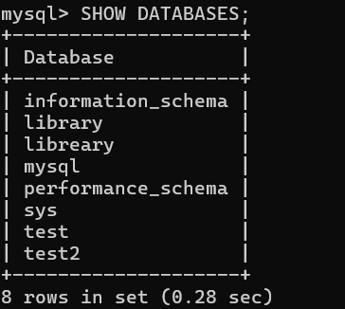
LIBRARY MODULE:

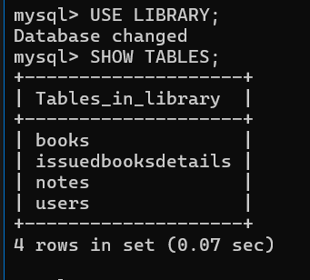
TABLES;

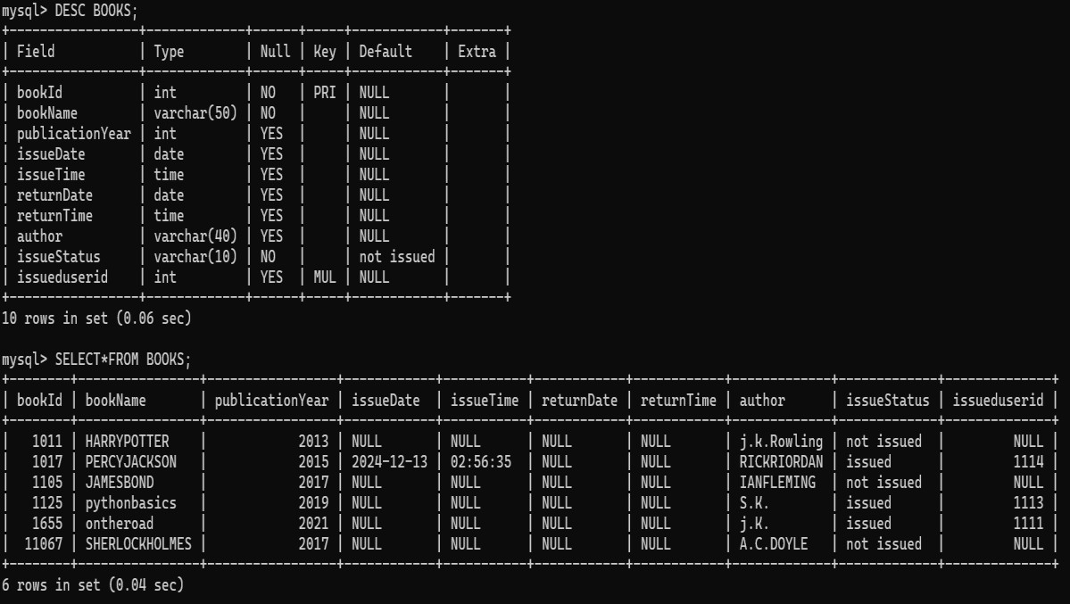
BOOKS TABLE;

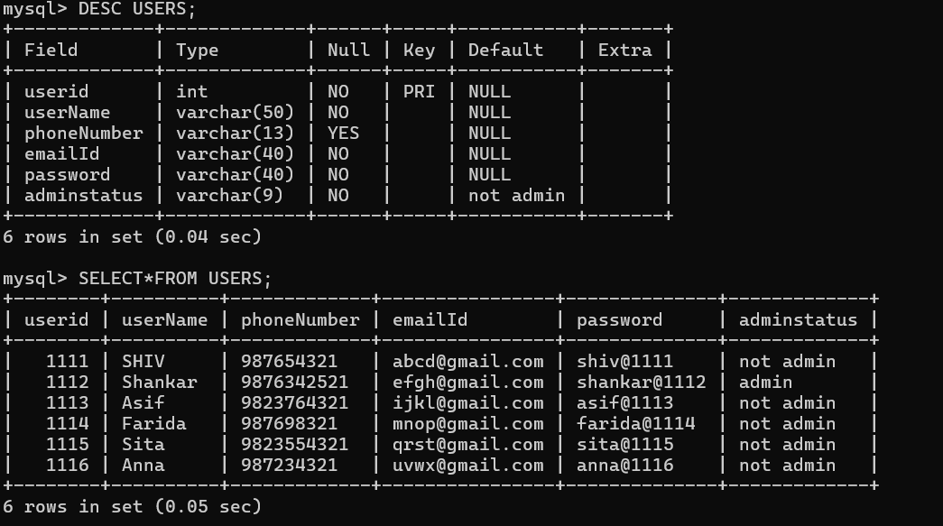
USERS TABLE;

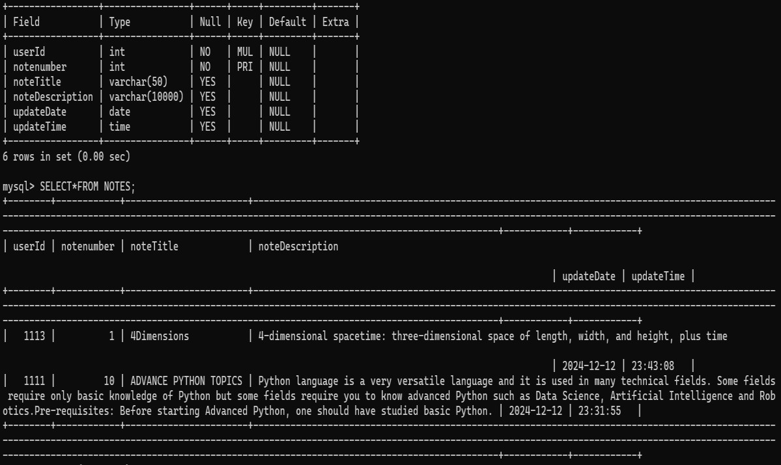
NOTES TABLE;

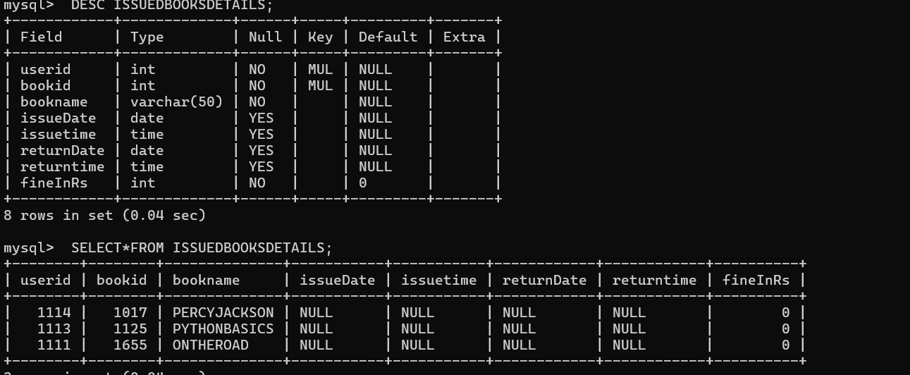
ISSUED BOOKS DETAILS TABLE;



PYTHON OUTPUT; HOME()
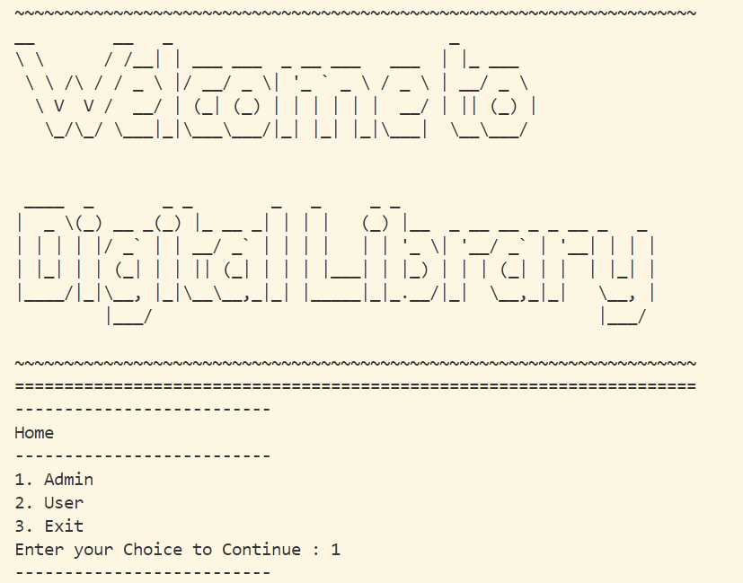

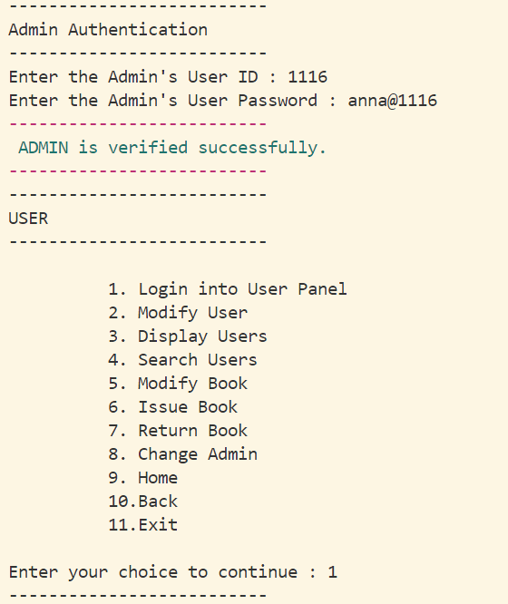
ADMIN AUTHENTICATION;

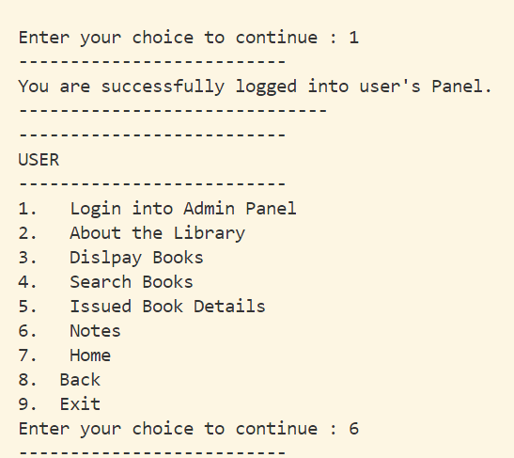
ADMIN TO USER PANEL;

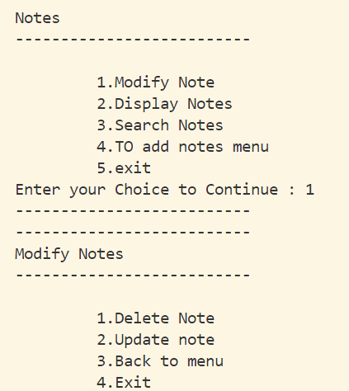
NOTES MENU;

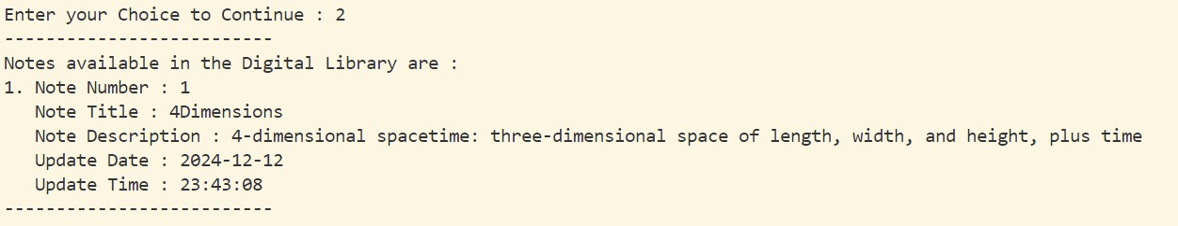
DISPLAY NOTE;

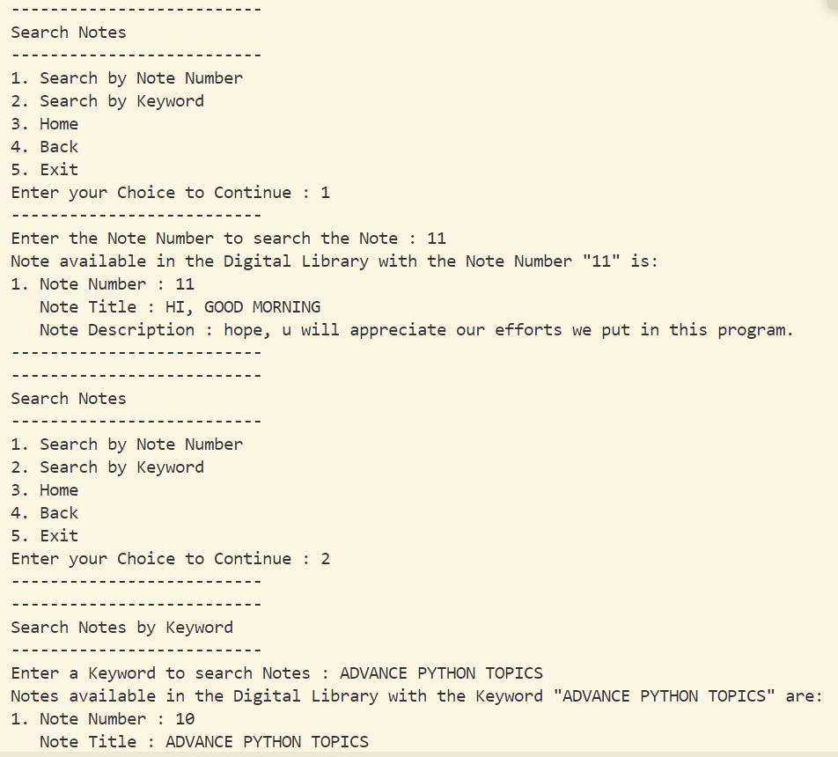
SEARCH NOTE;

MODIFY NOTE;
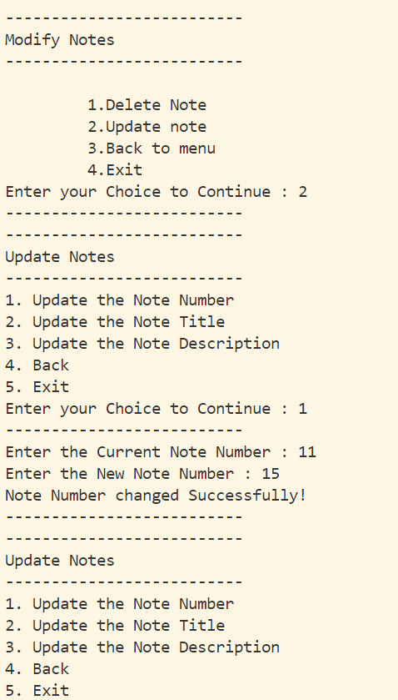

USER AUTHENTICATION;
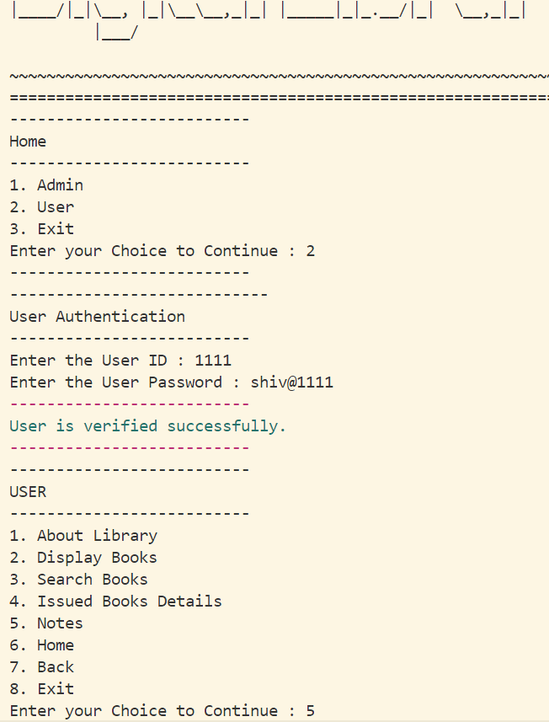

ABOUT LIBRARY
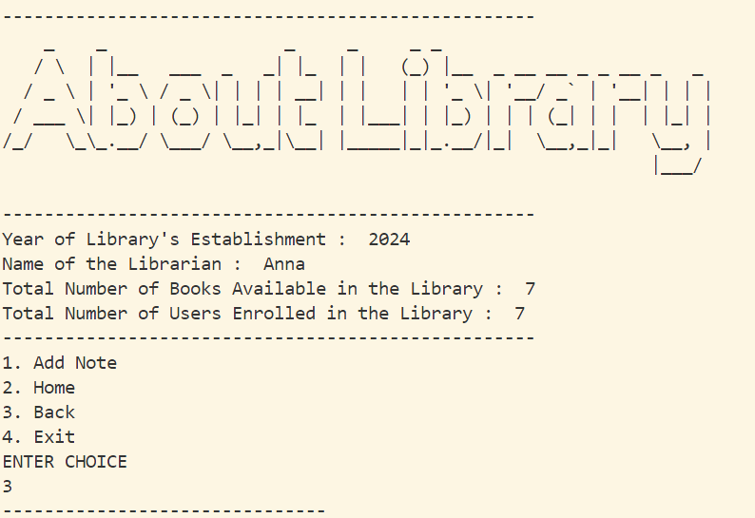

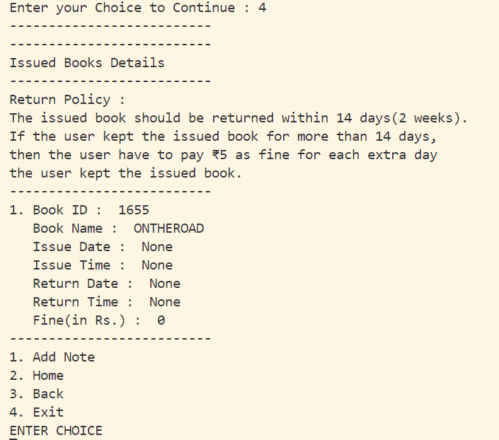
ISSUED BOOKS DETAILS;

DISPLAY BOOKS;
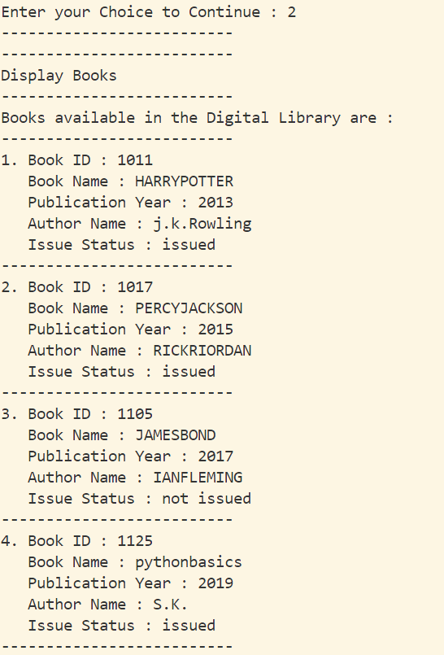

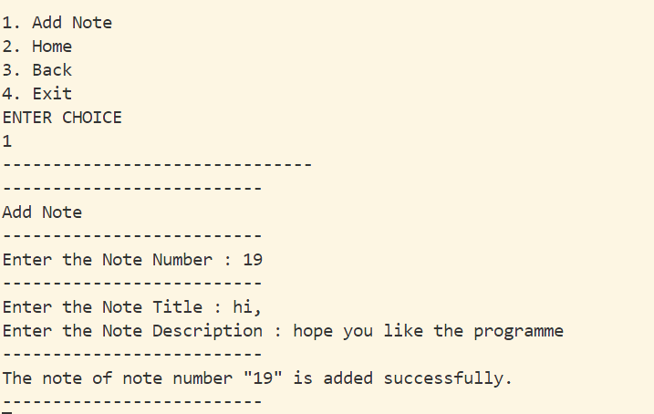
ADD NOTE;

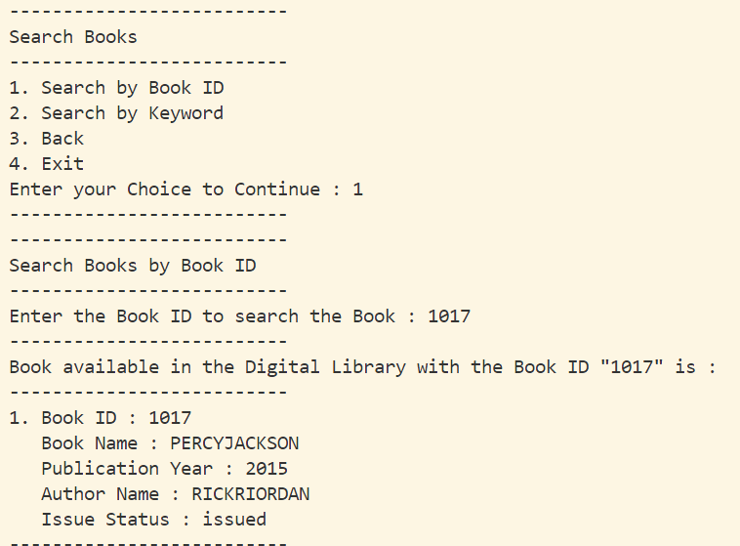
SEARCH BOOK;

BOOKS DATABASE MODIFICATION (BY ADMIN);
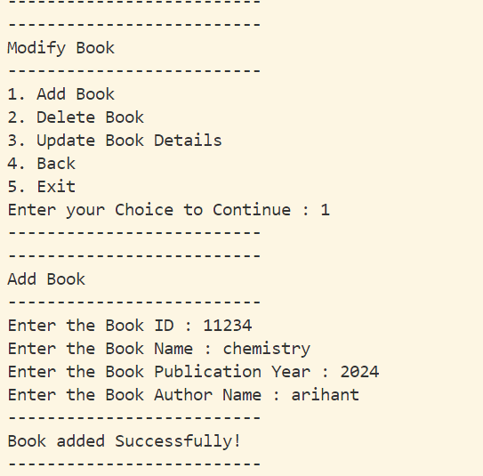
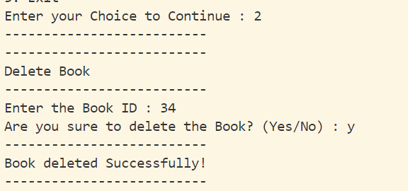

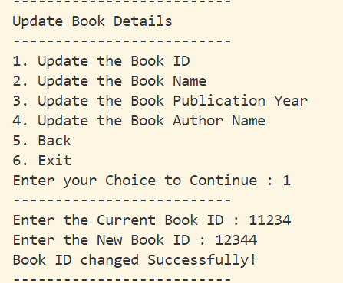
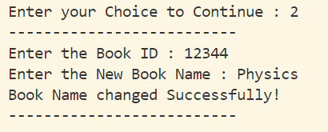
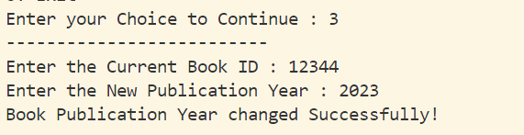
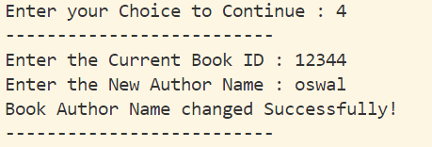
UPDATE BOOK;(BY ADMIN)

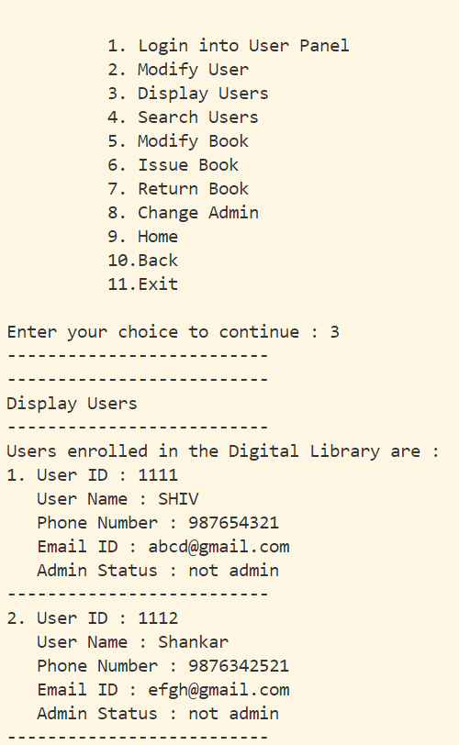
DISPLAY USERS TO ADMIN;

MODIFY USERS BY ADMIN(ADDING)
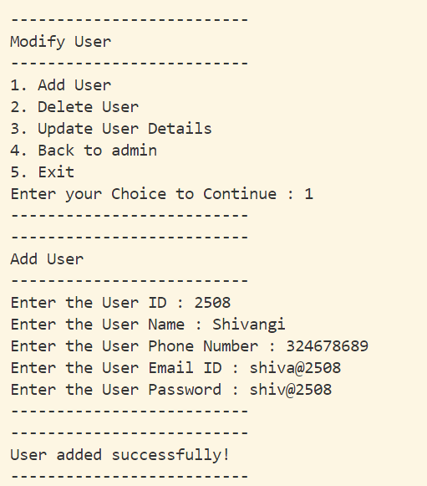

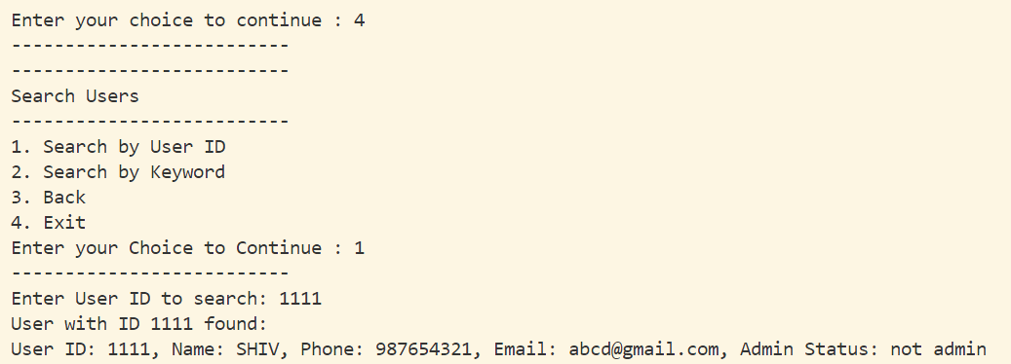
SEARCH USER;

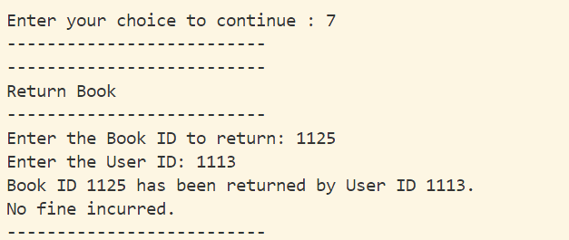
RETURN BOOK;

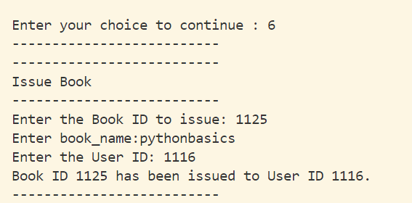
ISSUE BOOK;

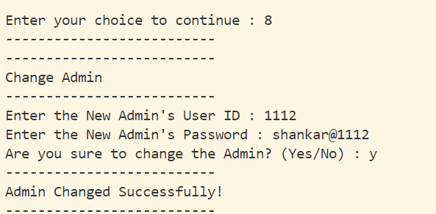
CHANGING ADMIN;

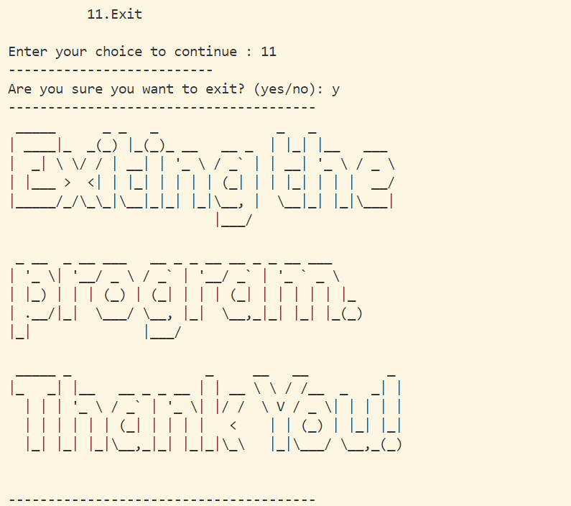
EXITING THE PROGRAM

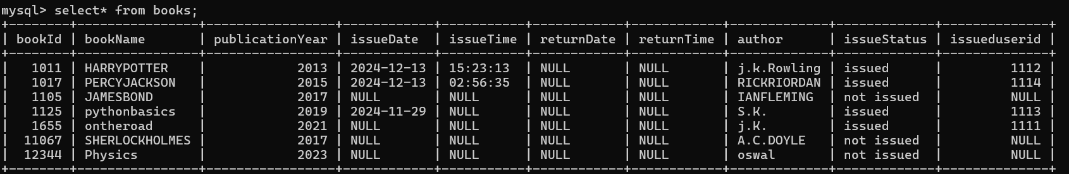
MYSQL AFTER CHANGES; BOOKS TABLE

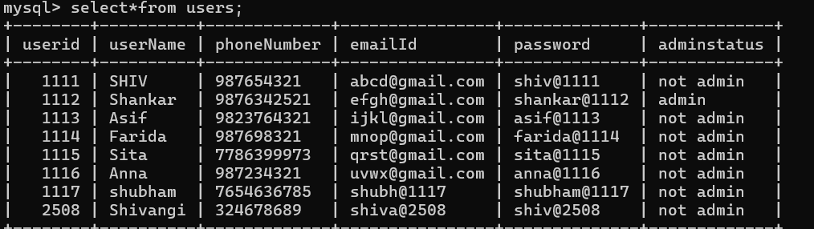
USERS TABLE

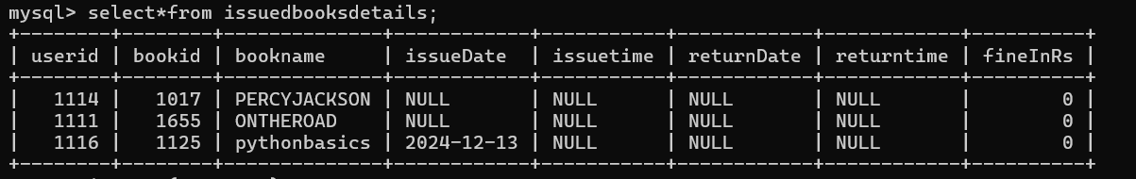
ISSUED BOOKS DETAILS

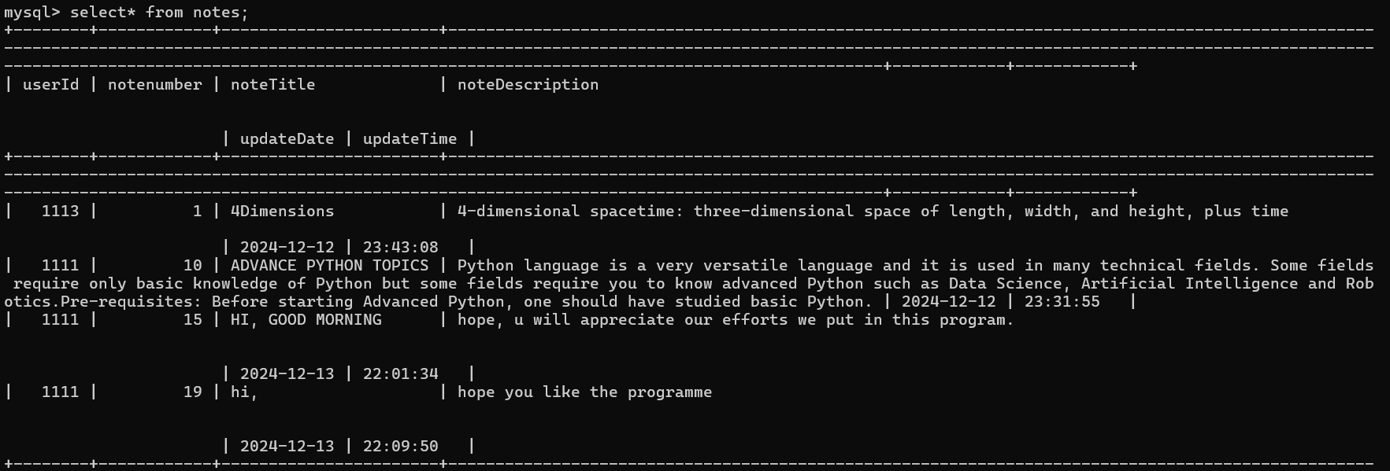
NOTES TABLE

TESTING
Software Testing is an empirical investigation conducted to provide stakeholders with information about the quality of the product or service under test, with respect to the context in which it is intended to operate. Software Testing also provides an objective, independent view of the software to allow the business to appreciate and understand the risks at implementation of the software. Test techniques include, but are not limited to, the process of executing a program or application with the intent of finding software bugs.
It can also be stated as the process of validating and verifying that a software program/application/product meets the business and technical requirements that guided its design and development, so that it works as expected and can be implemented with the same characteristics. Software Testing, depending on the testing method employed, can be implemented at any time in the development process, however the most test effort is employed after the requirements have been defined and coding process has been completed.

TESTING METHODS
Software testing methods are traditionally divided into black box testing and white box testing. These two approaches are used to describe the point of view that a test engineer takes when designing test cases.

BLACK BOX TESTING
Black box testing treats the software as a "black box," without any knowledge of internal implementation. Black box testing methods include: equivalence partitioning, boundary value analysis, all-pairs testing, fuzz testing, model-based testing, traceability matrix, exploratory testing and specification based testing.

SPECIFICATION-BASED TESTING
Specification-based testing aims to test the functionality of software according to the applicable requirements.[16] Thus, the tester inputs data into, and only sees the output from, the test object. This level of testing usually requires thorough test cases to be provided to the tester, who then can simply verify that for a given input, the output value (or behaviour), either "is" or "is not" the same as the expected value specified in the test case. Specification based testing is necessary, but it is insufficient to guard against certain risks

ADVANTAGES AND DISADVANTAGES
The black box tester has no "bonds" with the code, and a tester's perception is very simple: a code must have bugs. Using the principle, "Ask and you shall receive," black box testers find bugs where programmers don't. But, on the other hand, black box testing has been said to be "like a walk in a dark labyrinth without a flashlight," because the tester doesn't know how the software being tested was actually constructed.
That's why there are situations when (1) a black box tester writes many test cases to check something that can be tested by only one test case, and/or (2) some parts of the back end are not tested at all. Therefore, black box testing has the advantage of "an unaffiliated opinion," on the one hand, and the disadvantage of "blind exploring," on the other.

WHITE BOX TESTING
White box testing, by contrast to black box testing, is when the tester has access to the internal data structures and algorithms (and the code that implement these)

TYPE OF WHITE BOX
api testing - testing of the application using public and private apis.
code coverage - creating tests to satisfy some criteria of code coverage.For example, the test designer can create tests to cause all statements in the program to be executed at least once.
fault injection methods. mutation testing methods.
static testing - white box testing includes all static testing.

CODE COMPLETENESS EVALUATION
White box testing methods can also be used to evaluate the completeness of a test suite that was created with black box testing methods. This allows the software team to examine parts of a system that are rarely tested and ensures that the most important function points have been tested.
Two common forms of code coverage are:
Function Coverage: Which reports on functions executed
Statement Coverage: Which reports on the number of lines executed to complete the test.

Bibliography

WEBSITES
- www.google.com
- www.w3school.com
- www.geekforgeeks.com
- www.python.org
- www.wikipedia.com
- www.youtube.com
- www.microsoft.com
- www.cbse.nic.in

BOOKS
  - CLASS 12 SUMITA ARORA PYTHON
  - CLASS 12 PREETI ARORA PYTHON
  - CLASS 12 NCERT

